Department of Computer Applications
18MX24 – DBMS – Sample Questions
Assignment [co1 and co2]

- Why would you choose a database system instead of simply storing data in operating system files? When would it make sense not to use a database system?
A database is an integrated collection of data, usually so large that it has to be stored on secondary storage devices such as disks or tapes. This data can be maintained as a collection of operating system files, or stored in a DBMS (database management system). The advantages of using a DBMS are:
Data independence and efficient access. Database application programs are independent of the details of data representation and storage. The conceptual and external schemas provide independence from physical storage decisions and logical design decisions respectively. In addition, a DBMS provides efficient storage and retrieval mechanisms, including support for very large files, index structures and query optimization.
Reduced application development time. Since the DBMS provides several important functions required by applications, such as concurrency control and crash recovery, high level query facilities, etc., only application-specific code needs to be written. Even this is facilitated by suites of application development tools available from vendors for many database management systems.
Data integrity and security. The view mechanism and the authorization facilities of a DBMS provide a powerful access control mechanism. Further, updates to the data that violate the semantics of the data can be detected and rejected by the DBMS if users specify the appropriate integrity constraints.
Data administration. By providing a common umbrella for a large collection of data that is shared by several users, a DBMS facilitates maintenance and data administration tasks. A good DBA can effectively shield end-users from the chores of fine-tuning the data representation, periodic back-ups etc.
Concurrent access and crash recovery. A DBMS supports the notion of a transaction, which is conceptually a single user’s sequential program. Users can write transactions as if their programs were running in isolation against the database. The DBMS executes the actions of transactions in an interleaved fashion to obtain good performance, but schedules them in such a way as to ensure that conflicting operations are not permitted to proceed concurrently. Further, the DBMS maintains a continuous log of the changes to the data, and if there is a system crash, it can restore the database to a transaction-consistent state. That is, the actions of incomplete transactions are undone, so that the database state reflects only the actions of completed transactions. Thus, if each complete transaction, executing alone, maintains the consistency criteria, then the database state after recovery from a crash is consistent.

If these advantages are not important for the application at hand, using a collection of files may be a better solution because of the increased cost and overhead of purchasing and maintaining a DBMS.
- What are the responsibilities of a DBA? If we assume that the DBA is never interested in running his or her own queries, does the DBA still need to understand query optimization? Why?
The DBA is responsible for:
- Designing the logical and physical schemas, as well as widely-used portions of the external schema.
- Security and authorization.
- Data availability and recovery from failures.
- Database tuning: The DBA is responsible for evolving the database, in particular the conceptual and physical schemas, to ensure adequate performance as user requirements change.
A DBA needs to understand query optimization even if s/he is not interested in running his or her own queries because some of these responsibilities (database design and tuning) are related to query optimization. Unless the DBA understands the performance needs of widely used queries, and how the DBMS will optimize and execute these queries, good design and tuning decisions cannot be made.
- Scrooge McNugget wants to store information (names, addresses, descriptions of embarrassing moments, etc.) about the many ducks on his payroll. Not surprisingly, the volume of data compels him to buy a database system. To save money, he wants to buy one with the fewest possible features, and he plans to run it as a stand-alone application on his PC alone. Of course, Scrooge does not plan to share his list with anyone. Indicate which of the following DBMS features Scrooge should pay for; in each case also indicate why Scrooge should (or should not) pay for that feature in the system he buys.
a) A security facility.
b) Concurrency control.
c) Crash recovery.
d) A view mechanism
e) A query language.
- What is the difference between the two-tier and three-tier client/server architectures?
All J2EE applications are broadly divided into two types. These are 2 tier or 3 tier architecture. Basically at high level we can say that 2-tier architecture is Client server application and 3-tier architecture is Web based application.Below we will concentrate on the difference between Two-Tier and Three-Tier Architecture, what all advantages and disadvantages they have.
Two-Tier Architecture: The two-tier is based on Client Server architecture. The two-tier architecture is like client server application. The direct communication takes place between client and server. There is no intermediate between client and server. Because of tight coupling a 2 tiered application will run faster.
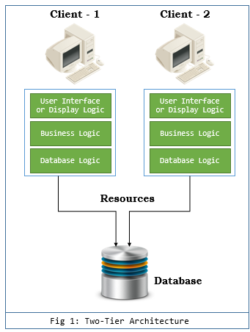
The above figure shows the architecture of two-tier. Here the direct communication happens between client and server, there is no intermediate layer between client and server. The Two-tier architecture is divided into two parts:
- Client Application (Client Tier)
- Database (Data Tier)
On client application side the code is written for saving the data in database server. Client sends the request to server and it process the request & send back with data. The main problem of two tier architecture is the server cannot respond multiple request same time, as a result it cause a data integrity issue. When the developers are not disciplined, the display logic, business logic and database logic are muddled up and/or duplicated in a 2tier client server system.
Advantages:
1. Easy to maintain and modification is bit easy.
2. Communication is faster.
Disadvantages:
1. In two tier architecture application performance will be degrade upon increasing the users.
2. Cost-ineffective.
Three-Tier Architecture : Three-tier architecture typically comprise a presentation tier, a business or data access tier, and a data tier. Three layers in the three tier architecture are as follows:
- Client layer
- Business layer
- Data layer
- Client layer: Represents Web browser, a Java or other application, Applet, WAP phone etc. The client tier makes requests to the Web server who will be serving the request by either returning static content if it is present in the Web server or forwards the request to either Servlet or JSP in the application server for either static or dynamic content.
- Business layer: This layer provides the business services. This tier contains the business logic and the business data. All the business logic like validation of data, calculations, data insertion etc. Are centralized into this tier as opposed to 2-tier systems where the business logic is scattered between the front end and the backend. The benefit of having a centralized business tier is that same business logic can support different types of clients like browser, WAP (Wireless Application Protocol) client, other standalone applications written in Java, C++, C# etc. This acts as an interface between Client layer and Data Access Layer. This layer is also called the intermediary layer helps to make communication faster between client and data layer.
- Data layer: This layer is the external resource such as a database, ERP system, Mainframe system etc. responsible for storing the data. This tier is also known as Data Tier. Data Access Layer contains methods to connect with database or other data source and to perform insert, update, delete, get data from data source based on our input data. Following diagram representing the 3-tier architecture.
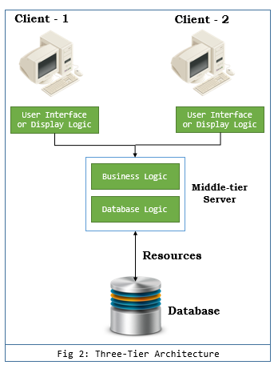
Advantages
1. High performance, lightweight persistent objects.
2. Scalability – Each tier can scale horizontally.
3. Performance – Because the Presentation tier can cache requests, network utilization is minimized, and the load is reduced on the Application and Data tiers.
4. Better Re-usability.
5. Improve Data Integrity.
6. Improved Security – Client is not direct access to database.
7. Forced separation of user interface logic and business logic.
8. Business logic sits on small number of centralized machines (may be just one).
9. Easy to maintain, to manage, to scale, loosely coupled etc.
Disadvantages
1. Increase Complexity/Effort

- Define the following terms:
data model:
database schema
database state,
internal schema,
conceptual schema,
external schema,
data independence,
DDL,
DML,
SDL,
VDL,
query language,
host language,
data sublanguage,
database utility,
catalog,
client/server architecture.
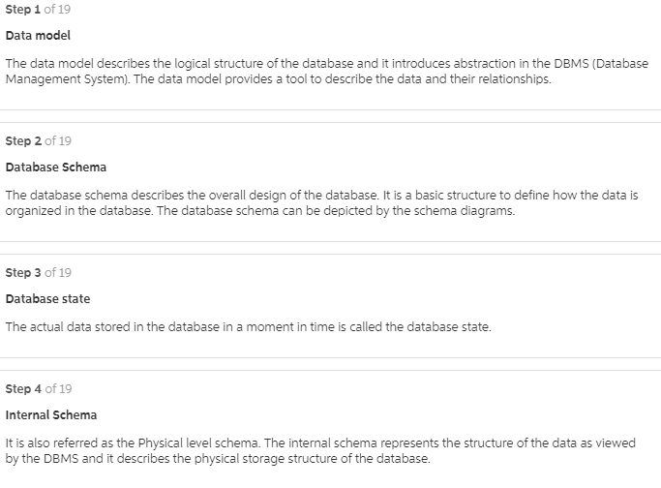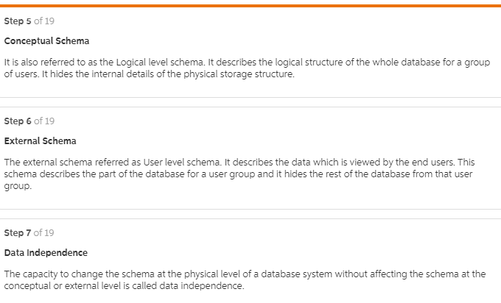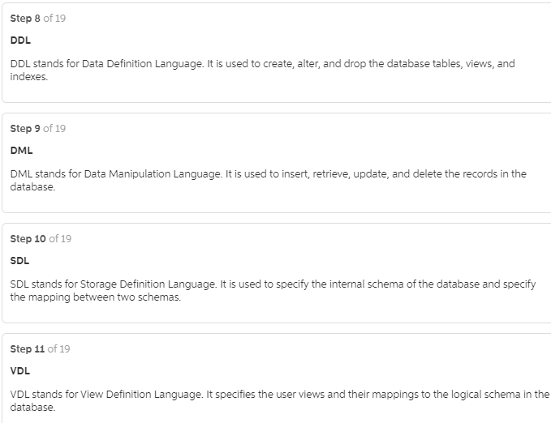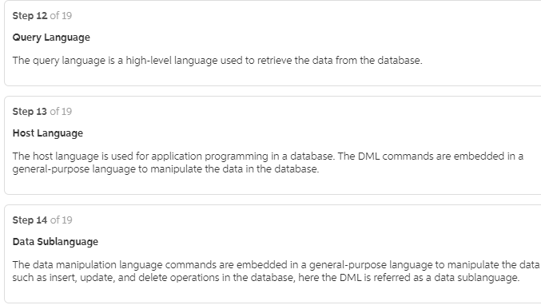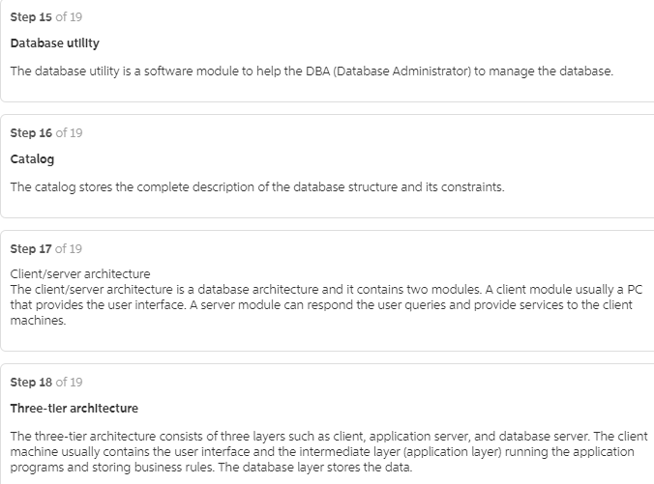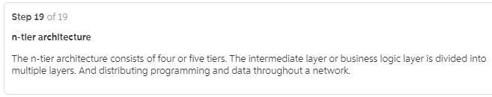
- Answer for the following questions. Google it to write the answer
- What is a transaction?
- Why does a DBMS interleave the actions of different transactions, instead of executing transactions one after the other?
- What must a user guarantee with respect to a transaction and database consistency?
- What should a DBMS guarantee with respect to concurrent execution of several transactions and database consistency?
- Explain the strict two-phase locking protocol.
- What is the WAL property, and why is it important?
  - A transaction is any one execution of a user program in a DBMS. This is the basic unit of change in a DBMS.
  - A DBMS is typically shared among many users. Transactions from these users can be interleaved to improve the execution time of users’ queries. By interleaving queries, users do not have to wait for other user’s transactions to complete fully before their own transaction begins. Without interleaving, if user A begins a transaction that will take 10 seconds to complete, and user B wants to begin a transaction, user B would have to wait an additional 10 seconds for user A’s transaction to complete before the database would begin processing user B’s request.
  - A user must guarantee that his or her transaction does not corrupt data or insert nonsense in the database. For example, in a banking database, a user must guarantee that a cash withdraw transaction accurately models the amount a person removes from his or her account. A database application would be worthless if a person removed 20 dollars from an ATM but the transaction set their balance to zero!
  - A DBMS must guarantee that transactions are executed fully and independently of other transactions. An essential property of a DBMS is that a transaction should execute atomically, or as if it is the only transaction running. Also, transactions will either complete fully, or will be aborted and the database returned to it’s initial state. This ensures that the database remains consistent.
  - Strict two-phase locking uses shared and exclusive locks to protect data. A transaction must hold all the required locks before executing, and does not release any lock until the transaction has completely finished.
  - The WAL property affects the logging strategy in a DBMS. The WAL, WriteAhead Log, property states that each write action must be recorded in the log (on disk) before the corresponding change is reflected in the database itself. This protects the database from system crashes that happen during a transaction’s execution. By recording the change in a log before the change is truly made, the database knows to undo the changes to recover from a system crash. Otherwise, if the system crashes just after making the change in the database but before the database logs the change, then the database would not be able to detect his change during crash recovery.

- Explain the following terms briefly:
Attribute- a property or description of an entity. A toy department employee entity could have attributes describing the employee’s name, salary, and years of service.
Domain- a set of possible values for an attribute.
Entity- an object in the real world that is distinguishable from other objects such as the green dragon toy
Relationship- an association among two or more entities.
entity set- a collection of similar entities such as all of the toys in the toy department.
relationship set- a collection of similar relationships
one-to-many relationship- a key constraint that indicates that one entity can be associated with many of another entity. An example of a one-to-many relationship is when an employee can work for only one department, and a department can have many employees.
many-to-many relationship- a key constraint that indicates that many of one entity can be associated with many of another entity. An example of a manyto-many relationship is employees and their hobbies: a person can have many different hobbies, and many people can have the same hobby.
participation constraint- a participation constraint determines whether relationships must involve certain entities. An example is if every department entity has a manager entity. Participation constraints can either be total or partial. A total participation constraint says that every department has a manager. A partial participation constraint says that every employee does not have to be a manager.
overlap constraint- within an ISA hierarchy, an overlap constraint determines whether or not two subclasses can contain the same entity.
covering constraint- within an ISA hierarchy, a covering constraint determines where the entities in the subclasses collectively include all entities in the superclass. For example, with an Employees entity set with subclasses HourlyEmployee and SalaryEmployee, does every Employee entity necessarily have to be within either HourlyEmployee or SalaryEmployee?
weak entity set-an entity that cannot be identified uniquely without considering some primary key attributes of another identifying owner entity. An example is including Dependent information for employees for insurance purposes.
aggregation- a feature of the entity relationship model that allows a relationship set to participate in another relationship set. This is indicated on an ER diagram by drawing a dashed box around the aggregation.
role indicator- If an entity set plays more than one role, role indicators describe the different purpose in the relationship. An example is a single Employee entity set with a relation Reports-To that relates supervisors and subordinates.
- A company database needs to store information about employees (identified by ssn, with salary and phone as attributes); departments (identified by dno, with dname and budget as attributes); and children of employees (with name and age as attributes). Employees work in departments; each department is managed by an employee; a child must be identified
uniquely by name when the parent (who is an employee; assume that only one parent works for the company) is known. We are not interested in information about a child once the parent leaves the company. Draw an ER diagram that captures this information.
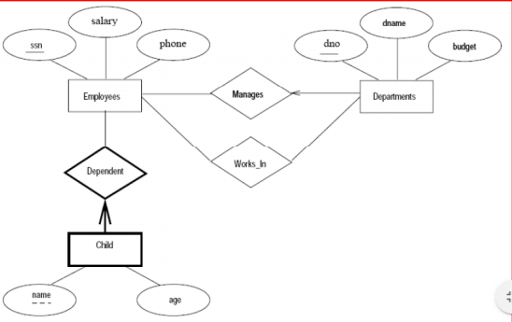
- List the various cases where use of a null value would be appropriate.
Null value would be appropriate when a particular entity does not have an applicable value for an attribute. There are two cases for such situations. Thefirst case arises when it is known that the attribute value exists but is missing.An example for cases like such would be if the Height attribute of a person is listed as null. The second case arises when it is not known whether the attribute value exists. An example would be is the HomePhone attribute of a person is null.
Define the following terms: entity, attribute, attribute value, relationship instance, composite attribute, multivalued attribute, derived attribute, complex attribute, key attribute, value set (domain).
Entity:Entity is a “thing” in the real world with an independent existence. It can also be an object with physical existence (i.e. person, car) or conceptual existence (i.e. company, job).
Attribute:An attribute is a particular property that describes entity (i.e. person name company name).
Attribute Value:Attribute values are major data stored in the database.
Relationship Instance:Relationship Instance is an association of entities, where the association includes exactly one entity from each participating entity type.
Composite Attribute:Composite attribute is an attribute that can be divided into meaningful components.
Multivalued Attribute:Multivalued attribute is an attribute that can have many values.
Derived Attribute:Derived attribute is an attribute whose value is computed from another attribute or combination of attributes.
Complex Attribute:Complex attribute is composite and multivalued attributes nested in an arbitrary manner.
Key Attribute:Key attribute is an attribute whose values are distinct for each individual entity in the collection.
Value Set (Domain):Value set specifies the set of values that may be assigned to that attribute for each individual entry.
- What is meant by a recursive relationship type? Give some examples of recursive
relationship types.
A recursive relationship type exists if an entity can be related to itself or ifthe same entity type participates more than once in a relationship type in different roles. Example of a recursive relationship type is courses that require one or more other courses as prerequisites. The course entity is related to another course entity. In this case, the recursive relationship “course is a prerequisite to course” also happens to be a M:N relationship. This is because a course can have more than one prerequisite, and a course can be a prerequisite to many other courses. Another example of a recursive relationship type is in a supervision relationship.
- Composite and multivalued attributes can be nested to any number of levels. Suppose we want to design an attribute for a STUDENT entity type to keep track of previous college education. Such an attribute will have one entry for each college
previously attended, and each such entry will be composed of college name, start and end dates, degree entries (degrees awarded at that college, if any), and transcript entries (courses completed at that college, if any). Each degree entry contains the degree name and the month and year the degree was awarded, and each transcript entry contains a course name, semester, year, and grade. Design an attribute to hold this information.
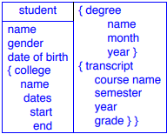
- A database is being constructed to keep track of the teams and games of a sports league. A team has a number of players, not all of whom participate in each game. It is desired to keep track of the players participating in each game for each team, the positions they played in that game, and the result of the game. Design an ER schema diagram for this application, stating any assumptions you make. Choose your favorite sport (e.g., soccer, baseball, football).
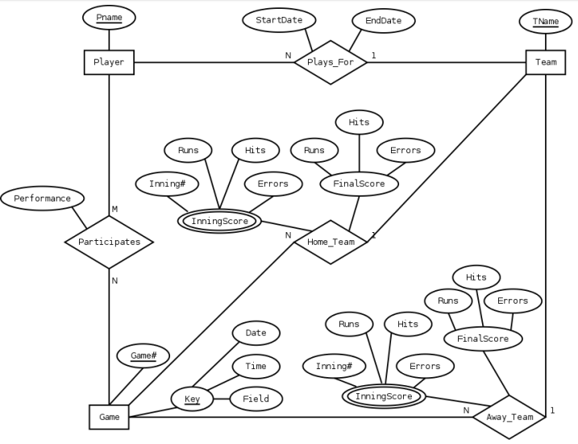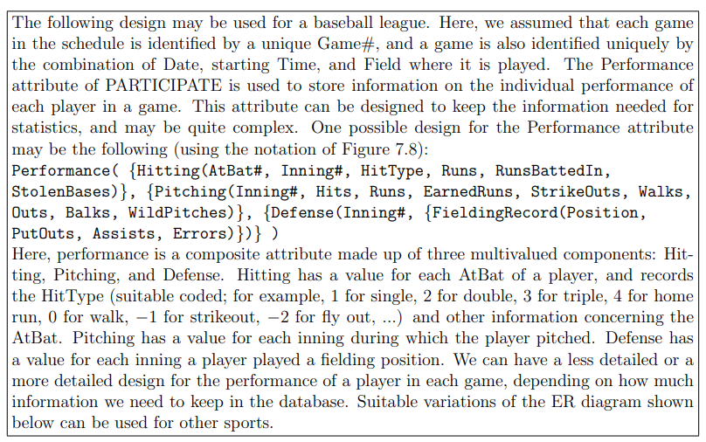
- Define the following terms: superclass of a subclass, superclass/subclass relationship, is-a relationship, specialization, generalization, category, specific (local) attributes) specific relationships.
- What is the difference between a specialization hierarchy and a specialization lattice?
Specialization:- When one higher level entity is broken in two lower level entities it is known as specialization, but there are exception of this entity in which some higher level entity do not have lower level entity. Specialization is opposite to generalization and it is top down process.
Specialization Hierarchy – has the constraint that every subclass participates as a subclass in only one class/subclass relationship, i.e. that each subclass has only one parent. This results in a tree structure. In specialization hierarchy it has only one parent and from that other classes are defined. It has the subclass and that subclass will be related to only class and this will form tree type structure.
Specialization Lattice – has the constraint that a subclass can be a subclass of more than one class/subclass relationship. In specialization lattice each constraint will have more than one subclass or parent class. Every class can be a subclass of more than one class.
In a lattice or hierarchy, the subclass inherits the attributes not only of the direct superclass, but also all of the predecessor super classes all the way to the root.
- Discuss the mechanism of attribute/relationship inheritance. Why is it useful?
- Design a database to keep track of information for an art museum. Assume that the following requirements were collected:
• The museum has a collection of ART_OBJECTS. Each ART_OBJECT has a unique IdNo, an Artist (if known), a Year (when it was created, if known), a Title, and a Description. The art objects are categorized in several ways, as discussed below.
• ART_OBJECTS are categorized based on their type. There are three main types: PAINTING, SCULPTURE, and STATUE, plus another type called OTHER to accommodate objects that do not fall into one of the three main types.
• A PAINTING has a PaintType (oil, watercolor, etc.), material on which it is DrawnOn (paper, canvas, wood, etc.), and Style (modem, abstract, erc.).
• A SCULPTURE or a STATUE has a Material from which it was created (wood, stone, etc.), Height, Weight, and Style.
• An art object in the OTHER category has a Type (print, photo, etc.) and Style.
• ART_OBJECTS are also categorized as PERMANENT_COLLECTION, which are owned by the museum (these have information on the DateAcquired, whether it is OnDisplay or stored, and Cost) or BORROWED, which has information on the Collection (from which it was borrowed), DateBorrowed, and DateRetumed.
• ART_OBJECTS also have information describing their country/culture using information on country/culture of Origin (Italian, Egyptian, American, Indian, etc.) and Epoch (Renaissance, Modem, Ancient, etc.).
• The museum keeps track of ARTIST'S information, if known: Name, DateBom (if known), DateDied (if not living), CountryOfOrigin, Epoch, MainStyle, and Description. The Name is assumed to be unique.
• Different EXHIBITIONS occur, each having a Name, StartDate, and EndDate. EXHIBITIONS are related to all the art objects that were on display during the exhibition.
• Information is kept on other COLLECTIONS with which the museum interacts, including Name (unique), Type (museum, personal, etc.), Description, Address, Phone, and current ContactPerson.
Draw an EER schema diagram for this application. Discuss any assumptions you made, and that justify your EER design choices.
- Why are tuples in a relation not ordered? Why are duplicate tuples not allowed in a relation? What is the difference between a key and a super key?
- Discuss the characteristics of relations that make them different from ordinary tables and files
- Define foreign key. When is this concept used for?
- Suppose that each of the following update operations is applied directly to the Employee [example]
database state discussed in the class. Discuss all integrity constraints violated by each operation, if any, and the different ways of enforcing these constraints.
a. Insert <Robert', 'F', 'Scott', '943775543', '1952-06-21', '2365 Newcastle Rd,
Bellaire, TX', M, 58000, '888665555',1> into EMPLOYEE.
b. Insert <'ProductA', 4, 'Bellaire', 2> into PROJECT.
c. Insert <'Production', 4, '943775543', '1998-10-01'> into DEPARTMENT.
d. Insert <'677678989', null, '40.0'> into WORKS_ON.
e. Insert <'453453453', 'John', M, '1970-12-12', 'SPOUSE'> into DEPENDENT.
f. Delete the WORKS_ON tuples with ESSN = '333445555'.
g. Delete the EMPLOYEE tuple with SSN = '987654321'.
h. Delete the PROJECT tuple with PNAME = 'ProductX'.
i. Modify the MGRSSN and MGRSTARTDATE of the DEPARTMENT tuple with DNUMBER = 5 to
'123456789' and '1999-10-01', respectively.
j. Modify the SUPERSSN attribute of the EMPLOYEE tuple with SSN = '999887777' to
'943775543'.
k. Modify the HOURS attribute of the WORKS_ON tuple with ESSN = '999887777' and PNO = 10 to '5.0'.
- Consider the following relations for a database that keeps track of student enrollment in courses and the books adopted for each course:
STUDENT(SSN, Name, Major, Bdate)
COURSE(Course#, Cname, Dept)
ENROLL(SSN, Course#, Quarter, Grade)
BOOK_ADOPTION(Course#, Quarter, Book_ISBN)
TEXT(Book_ISBN, BooLTitle, Publisher, Author)
Specify the foreign keys for this schema, stating any assumptions you make
- What is union compatibility? Why do the UNION, INTERSECTION, and DIFFERENCE operations require that the relations on which they are applied be union compatible?
- How are the OUTER JOIN operations different from the INNER JOIN operations? How is the OUTER UNION operation different from UNION?
- In what sense does relational calculus differ from relational algebra, and in what sense are they similar?
- How does tuple relational calculus differ from domain relational calculus?
- What is meant by a safe expression in relational calculus?
- Discuss the meanings of the existential quantifier and the universal quantifier
- Specify the following queries in relational algebra on the database schema given in Question No. 22
a). List the number of courses taken by all students named 'John Smith' in Winter
1999 (i.e., Quarter = 'W99').
b). Produce a list of textbooks {include Courses, BookISBN, Book, Title} for
courses offered by the 'CS' department that have used more than two books.
c). List any department that has all its adopted books published by ”AWL
Publishing”
- Consider the two tables shown below. Show the results of the following operations 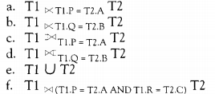 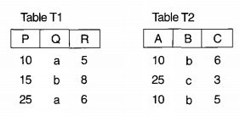
- In a tuple relational calculus query with n tuple variables, what would be the typical minimum number of join conditions? Why? What is the effect of having a smaller number of join conditions?
- Consider this query: Retrieve the SSNS of employees who work on at least those projects on which the employee with SSN = 123456789 works. This may be stated as (FORALL x) (IF P THEN Q), where
• x is a tuple variable that ranges over the PROJECT relation.
• P == employee with SSN = 123456789 works on project x.
• Q == employee e works on project x.
Express the query in tuple relational calculus, using the rules
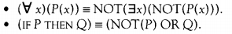
- Show how you may specify the following relational algebra operations in both tuple and domain relational calculus.
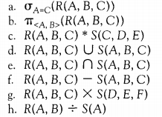
- Discuss the correspondences between the ER model constructs and the relational model constructs. Show how each ER model construct can be mapped to the relational model, and discuss any alternative mappings.
- Discuss the options for mapping EER model constructs to relations

